1) Calories_consumed-> predict weight gained using calories consumed

**Ans :**

**R Code :**

## Simple Linear Regression

########## Calories Consumed Data Set #########

calories <- read.csv('D:\\Data Science\\Excelr\\Assignments\\Assignment\\Simple Linear Regression\\calories_consumed.csv')

CC <- calories$Calories.Consumed

WG <- calories$Weight.gained..grams.

boxplot(CC, col="dodgerblue4")

boxplot(WG,col="dodgerblue4")

plot(WG,CC,main="Scatter Plot",

col="Dodgerblue4",

col.main="Dodgerblue4",

col.lab="Dodgerblue4",

xlab="Weight Gained in grams",

ylab="Calories COnsumed", pch=20)

reg.model<-lm(WG~CC, data=calories)

summary(reg.model)

plot(CC,WG,main="Line of Best Fit",col="Dodgerblue4", col.main="Dodgerblue4")

abline(reg.model, col="red")

res <- signif(residuals(reg.model))

pre <- predict(reg.model)

segments(CC, WG, CC, pre)

predict(reg.model,newdata= data.frame(CC=c(2800,2900)))

**Results :**

> reg.model<-lm(WG~CC, data=calories)

> summary(reg.model)

Call:

lm(formula = WG ~ CC, data = calories)

Residuals:

Min 1Q Median 3Q Max

-158.67 -107.56 36.70 81.68 165.53

Coefficients:

Estimate Std. Error t value Pr(>|t|)

(Intercept) -625.75236 100.82293 -6.206 4.54e-05 ***

CC 0.42016 0.04115 10.211 2.86e-07 ***

---

Signif. codes: 0 ‘***’ 0.001 ‘**’ 0.01 ‘*’ 0.05 ‘.’ 0.1 ‘ ’ 1

Residual standard error: 111.6 on 12 degrees of freedom

Multiple R-squared: 0.8968, Adjusted R-squared: 0.8882

F-statistic: 104.3 on 1 and 12 DF, p-value: 2.856e-07

> predict(reg.model,newdata= data.frame(CC=c(2800,2900)))

1 2

550.6862 592.7019

**Plots :**

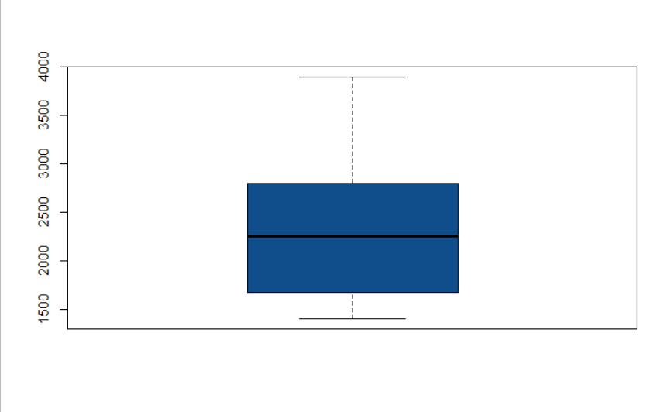

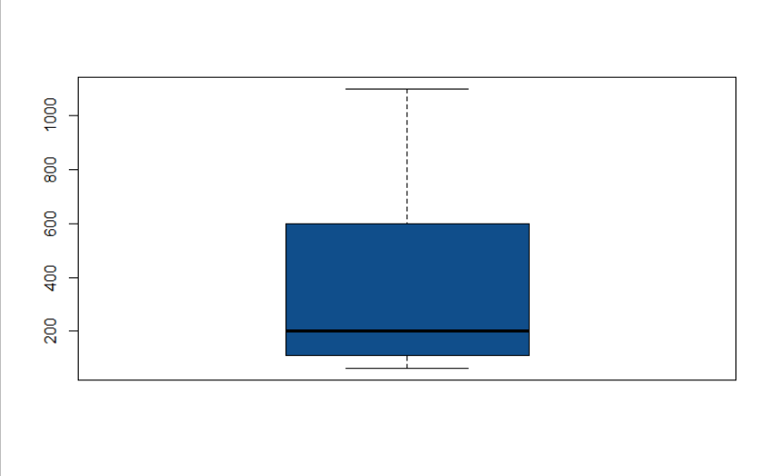

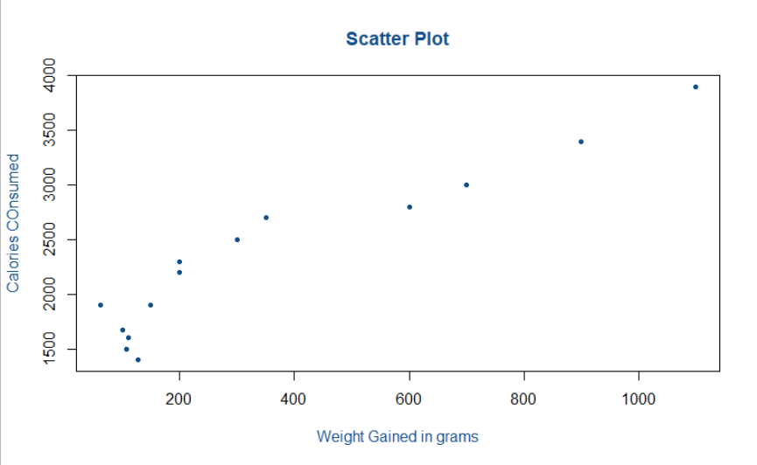

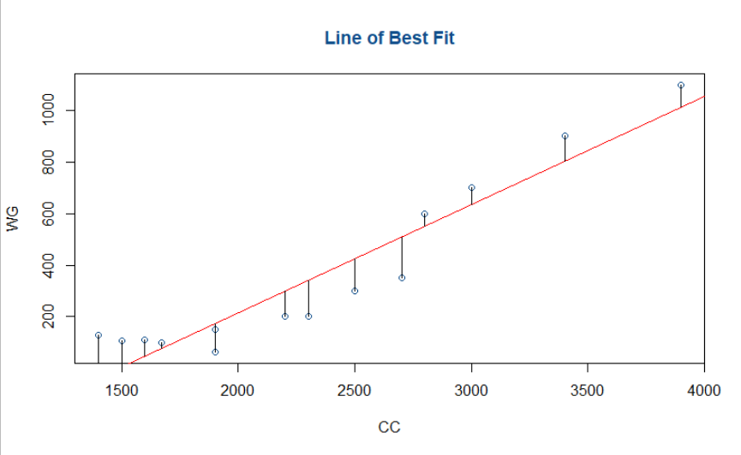

**Inference :**

Getting good R squared value of 0.89.